**RIP实验（选做）**

**实验7-1 RIP实验**

**学习目标**

* 了解RIP协议。
* 配置RIP，使总校区全网互联互通
* 在路由器上启动RIPv2 路由进程
* 启用参与路由协议的接口，并且通告网络

**原理**

动态路由协议包括距离向量路由协议和链路状态路由协议。RIP（Routing InformationProtocols，路由信息协议）是使用最广泛的距离向量路由协议。RIP 是为小网络环境设计的，因为这类协议的路由学习及路由更新将产生较大的流量，占用过多的带宽。

RIP 是由Xerox 在70 年代开发的，最初定义在RFC1058 中。RIP 用两种数据包传输更新：更新和请求，每个有RIP 功能的路由器默认情况下每隔30 秒利用UDP 520 端口向与它直连的网络邻居广播（RIP v1）或组播（RIP v2）路由更新。因此路由器不知道网络的全局情况，如果路由更新在网络上传播慢，将会导致网络收敛较慢，造成路由环路。为了避免路由环路，RIP 采用水平分割、毒性逆转、定义最大跳数、闪式更新、抑制计时5 个机制避免路由环路。

RIP 协议分为版本1 和版本2。不论是版本1 或版本2，都具备下面的特征：

1. 是距离向量路由协议；

2. 使用跳数（Hop Count）作为度量值；

3．默认路由更新周期为30 秒；

4. 管理距离（AD）为120；

5. 支持触发更新；

6. 最大跳数为15 跳；

7. 支持等价路径,默认4 条,最大6 条；

8. 使用UDP520 端口进行路由更新。

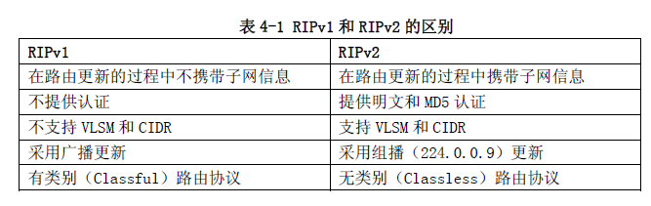

**拓扑图**

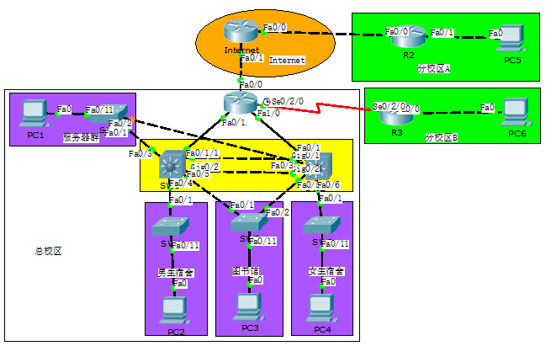

图1拓扑

**操作步骤**

将《DHCP实验》中保存的拓扑打开， 总校区中出口路由器R1，汇聚交换机SW1和SW2需要部署RIP，动态学习路由条目。

1. 在R1上配置RIP
2. 查看R1各接口IP地址

|  |
| --- |
| *R1#show ip int b*  *Interface IP-Address OK? Method Status Protocol*  *FastEthernet0/0 100.0.0.2 YES manual up up*  *FastEthernet0/1 10.0.130.1 YES manual up up*  *Serial0/2/0 10.0.130.129 YES unset up up*  *FastEthernet1/0 10.0.130.5 YES manual up up*  *FastEthernet1/1 unassigned YES unset administratively down down*  *Loopback0 10.0.128.1 YES manual up up*  *R1#* |

1. R1上配置RIP协议

|  |
| --- |
| *R1(config)#router rip //进入RIP模式*  *R1(config-router)#version 2 //设置RIP版本2*  *R1(config-router)#network 10.0.0.0 //开启各接口RIP，连Inetnet的接口不开启RIP*  *R1(config-router)#default-information originate //下发缺省路由，只在R1上配置* |

在R1上查看RIP 的datebase。

|  |
| --- |
| *R1#show ip rip database*  *R1#show ip rip database*  *0.0.0.0/0 auto-summary*  *0.0.0.0/0*  *[0] via 0.0.0.0, 01:18:07*  *10.0.0.0/24 is possibly down*  *10.0.0.0/24 is possibly down is possibly down*  *10.0.1.0/24 is possibly down*  *10.0.1.0/24 is possibly down*  *10.0.2.0/24 is possibly down*  *10.0.2.0/24 is possibly down is possibly down*  *10.0.3.0/24 is possibly down*  *10.0.3.0/24 is possibly down*  *10.0.128.1/32 auto-summary*  *10.0.128.1/32 directly connected, Loopback0*  *10.0.129.0/24 is possibly down*  *10.0.129.0/24 is possibly down is possibly down*  *10.0.130.0/30 auto-summary*  *10.0.130.0/30 directly connected, FastEthernet0/1*  *10.0.130.4/30 auto-summary*  *10.0.130.4/30 directly connected, FastEthernet1/0*  *10.0.130.8/30 is possibly down*  *10.0.130.8/30 is possibly down is possibly down*  *10.0.130.128/30 auto-summary*  *10.0.130.128/30 directly connected, Serial0/0* |

1. 在SW1和SW2上配置RIP
2. 查看SW1各接口IP地址

|  |
| --- |
| *SW1#show ip int b*  *Interface IP-Address OK? Method Status Protocol*  *Vlan2 10.0.129.1 YES manual up up*  *Vlan11 10.0.130.2 YES manual up up*  *Vlan13 10.0.130.9 YES manual up up*  *Vlan101 10.0.0.251 YES manual up up*  *Vlan102 10.0.1.1 YES manual up up*  *Vlan103 10.0.2.251 YES manual up up* |

1. SW1上配置RIP协议

|  |
| --- |
| *SW1(config)#router rip //进入RIP模式*  *SW1(config-router)#version 2 //设置RIP版本2*  *SW1(config-router)#network 10.0.0.0 //开启各接口RIP，连Inetnet的接口不开启RIP* |

1. 查看SW2各接口IP地址

|  |
| --- |
| *SW2#show ip int b*  *Interface IP-Address OK? Method Status Protocol*  *Vlan2 10.0.129.2 YES manual up up*  *Vlan11 10.0.130.6 YES manual up up*  *Vlan13 10.0.130.10 YES manual up up*  *Vlan101 10.0.0.252 YES manual up up*  *Vlan103 10.0.2.252 YES manual up up*  *Vlan104 10.0.3.1 YES manual up up* |

1. SW2上配置RIP协议

|  |
| --- |
| *SW2(config)#router rip //进入RIP模式*  *SW2(config-router)#version 2 //设置RIP版本2*  *SW2(config-router)#network 10.0.0.0 //开启各接口RIP，连Inetnet的接口不开启RIP* |

1. 在各设备上查看IP路由表
2. 在R1上查看IP路由表

|  |
| --- |
| *R1#show ip route*  *Gateway of last resort is 100.0.0.1 to network 0.0.0.0*  *10.0.0.0/8 is variably subnetted, 10 subnets, 3 masks*  *R 10.0.0.0/24 [120/1] via 10.0.130.2, 00:00:04, FastEthernet0/1*  *[120/1] via 10.0.130.6, 00:00:01, FastEthernet1/0*  *R 10.0.1.0/24 [120/1] via 10.0.130.2, 00:00:04, FastEthernet0/1*  *R 10.0.2.0/24 [120/1] via 10.0.130.2, 00:00:04, FastEthernet0/1*  *[120/1] via 10.0.130.6, 00:00:01, FastEthernet1/0*  *R 10.0.3.0/24 [120/1] via 10.0.130.6, 00:00:01, FastEthernet1/0*  *C 10.0.128.1/32 is directly connected, Loopback0*  *R 10.0.129.0/24 [120/1] via 10.0.130.2, 00:00:04, FastEthernet0/1*  *[120/1] via 10.0.130.6, 00:00:01, FastEthernet1/0*  *C 10.0.130.0/30 is directly connected, FastEthernet0/1*  *C 10.0.130.4/30 is directly connected, FastEthernet1/0*  *R 10.0.130.8/30 [120/1] via 10.0.130.2, 00:00:04, FastEthernet0/1*  *[120/1] via 10.0.130.6, 00:00:01, FastEthernet1/0*  *C 10.0.130.128/30 is directly connected, Serial0/0*  *100.0.0.0/24 is subnetted, 1 subnets*  *C 100.0.0.0 is directly connected, FastEthernet0/0*  *S* 0.0.0.0/0 [1/0] via 100.0.0.1* |

1. 在SW1上查看IP路由表

|  |
| --- |
| *SW1#show ip route*  *Gateway of last resort is 10.0.130.1 to network 0.0.0.0*  *10.0.0.0/8 is variably subnetted, 10 subnets, 3 masks*  *C 10.0.0.0/24 is directly connected, Vlan101*  *C 10.0.1.0/24 is directly connected, Vlan102*  *C 10.0.2.0/24 is directly connected, Vlan103*  *R 10.0.3.0/24 [120/1] via 10.0.129.2, 00:00:15, Vlan2*  *[120/1] via 10.0.130.10, 00:00:15, Vlan13*  *[120/1] via 10.0.0.252, 00:00:15, Vlan101*  *[120/1] via 10.0.2.252, 00:00:15, Vlan103*  *R 10.0.128.1/32 [120/1] via 10.0.130.1, 00:00:20, Vlan11*  *C 10.0.129.0/24 is directly connected, Vlan2*  *C 10.0.130.0/30 is directly connected, Vlan11*  *R 10.0.130.4/30 [120/1] via 10.0.130.1, 00:00:20, Vlan11*  *[120/1] via 10.0.129.2, 00:00:15, Vlan2*  *[120/1] via 10.0.130.10, 00:00:15, Vlan13*  *[120/1] via 10.0.0.252, 00:00:15, Vlan101*  *C 10.0.130.8/30 is directly connected, Vlan13*  *R 10.0.130.128/30 [120/1] via 10.0.130.1, 00:00:20, Vlan11*  *R* 0.0.0.0/0 [120/1] via 10.0.130.1, 00:00:20, Vlan11* |

1. 在SW2上查看IP路由表

|  |
| --- |
| *SW2#show ip route*  *Gateway of last resort is 10.0.130.5 to network 0.0.0.0*  *10.0.0.0/8 is variably subnetted, 10 subnets, 3 masks*  *C 10.0.0.0/24 is directly connected, Vlan101*  *R 10.0.1.0/24 [120/1] via 10.0.129.1, 00:00:06, Vlan2*  *[120/1] via 10.0.130.9, 00:00:06, Vlan13*  *[120/1] via 10.0.0.251, 00:00:06, Vlan101*  *[120/1] via 10.0.2.251, 00:00:06, Vlan103*  *C 10.0.2.0/24 is directly connected, Vlan103*  *C 10.0.3.0/24 is directly connected, Vlan104*  *R 10.0.128.1/32 [120/1] via 10.0.130.5, 00:00:03, Vlan12*  *C 10.0.129.0/24 is directly connected, Vlan2*  *R 10.0.130.0/30 [120/1] via 10.0.129.1, 00:00:06, Vlan2*  *[120/1] via 10.0.130.9, 00:00:06, Vlan13*  *[120/1] via 10.0.0.251, 00:00:06, Vlan101*  *[120/1] via 10.0.2.251, 00:00:06, Vlan103*  *C 10.0.130.4/30 is directly connected, Vlan12*  *C 10.0.130.8/30 is directly connected, Vlan13*  *R 10.0.130.128/30 [120/1] via 10.0.130.5, 00:00:03, Vlan12*  *R* 0.0.0.0/0 [120/1] via 10.0.130.5, 00:00:03, Vlan12* |

1. **路由业务测试**
2. 在PC2上对全网地址进行ping测。

|  |
| --- |
|  |

1. **保存配置**
2. 全网设备保存配置，防止掉电配置丢失。

参考配置：

*R1#wr //各设备特权模式下保存配置*

*Building configuration...*

*[OK]*

*R1#*

1. 查看全网设备配置保存是否成功，防止掉电配置丢失。

参考配置：

*R1#show startup-config //特权模式下查看保存的配置*

1. 保存拓扑。

单击“保存”，保存拓扑信息。

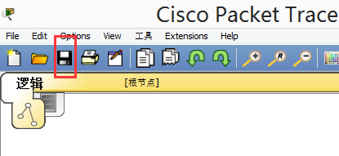

1. 以学号+名字+日期命名拓扑并保存，用U盘带走文件。

